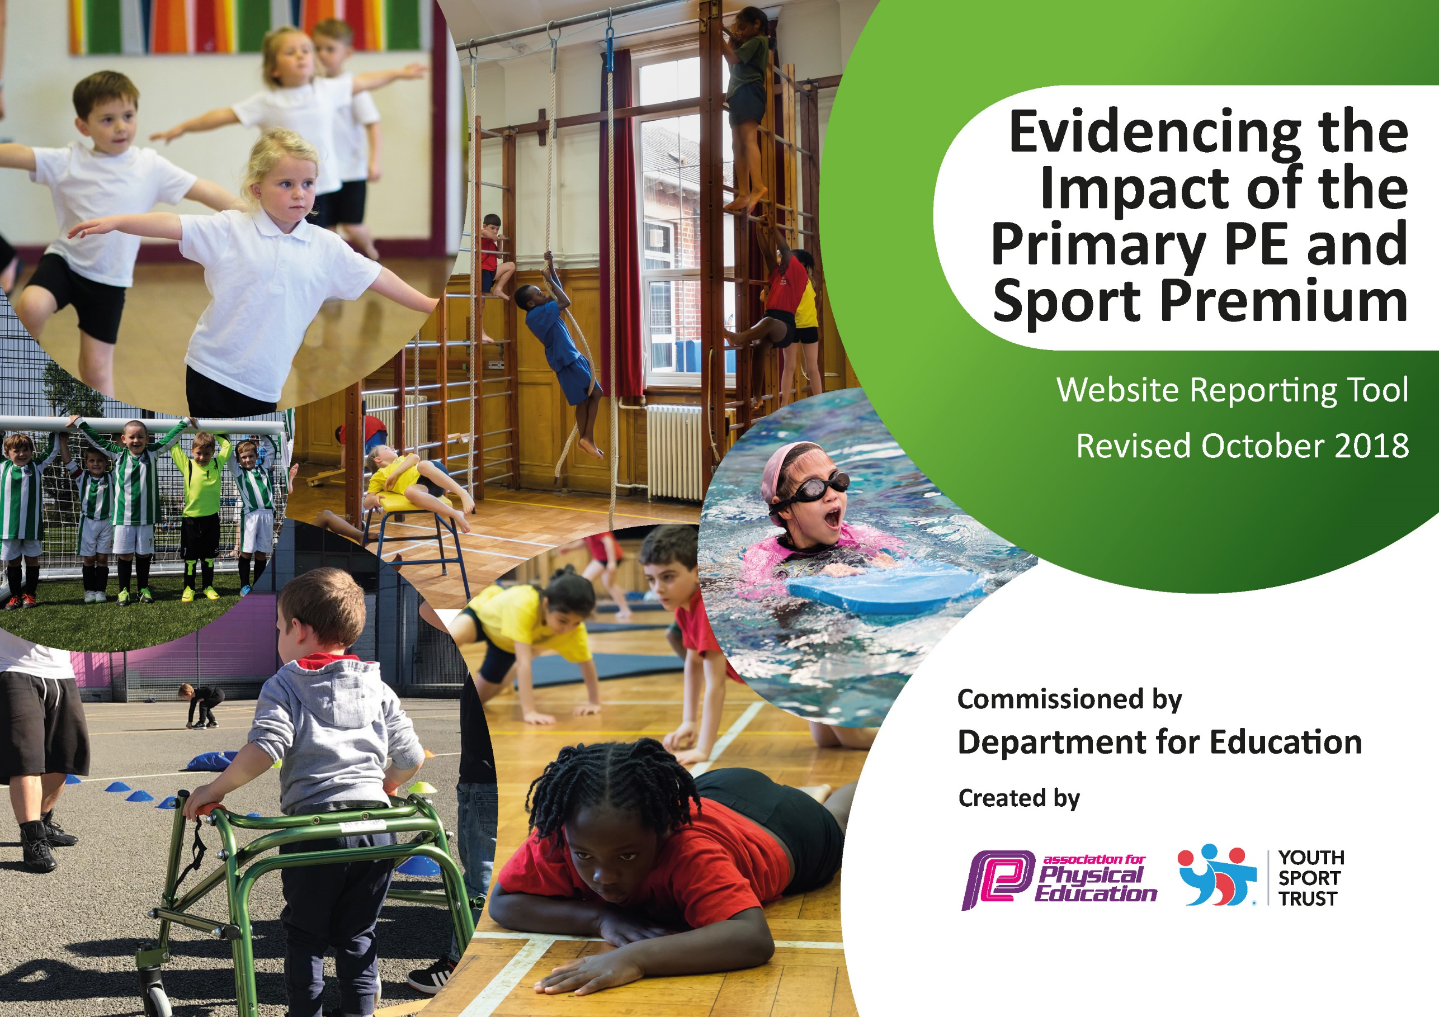
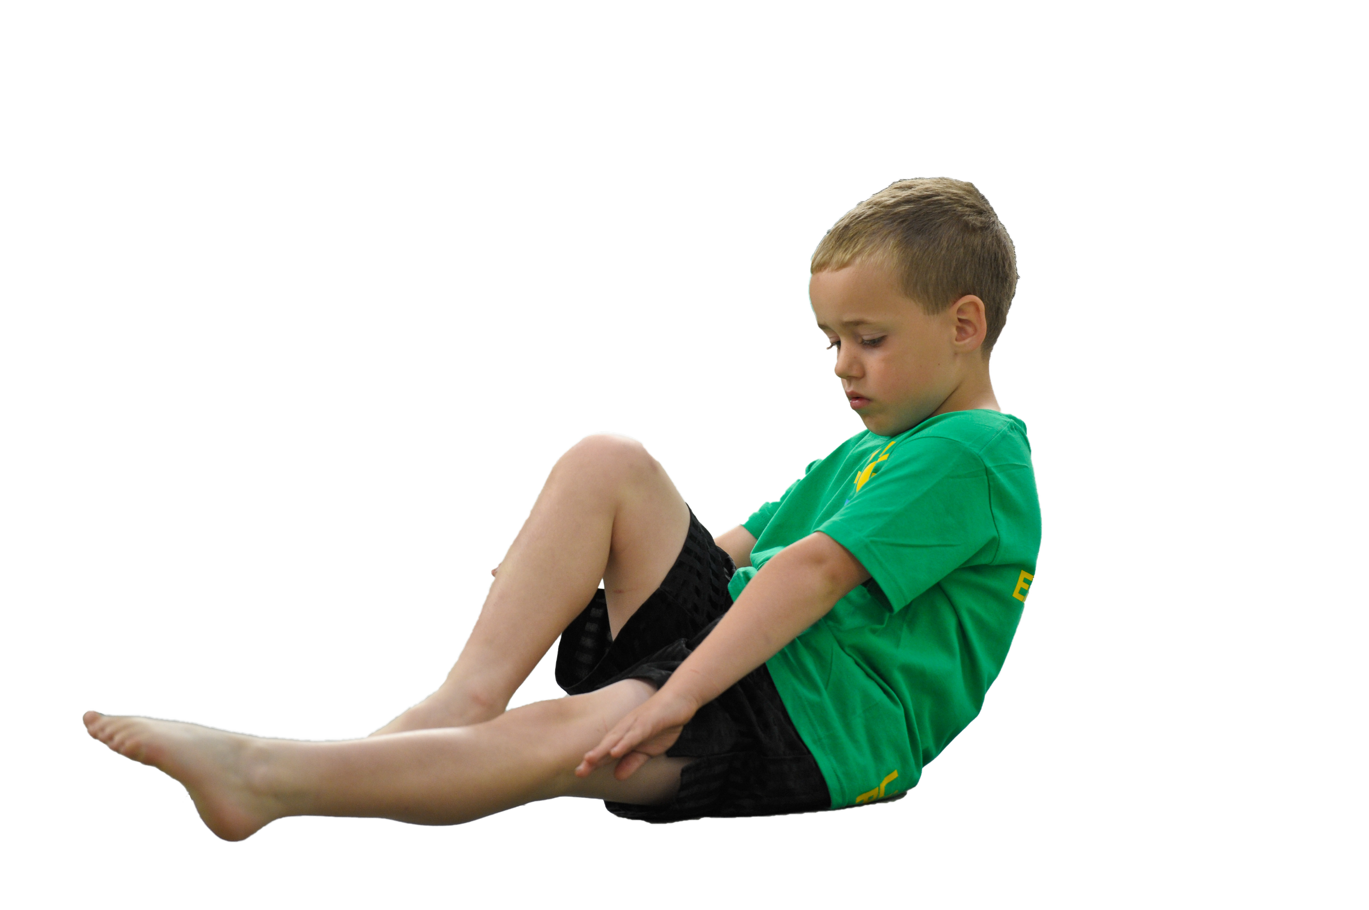
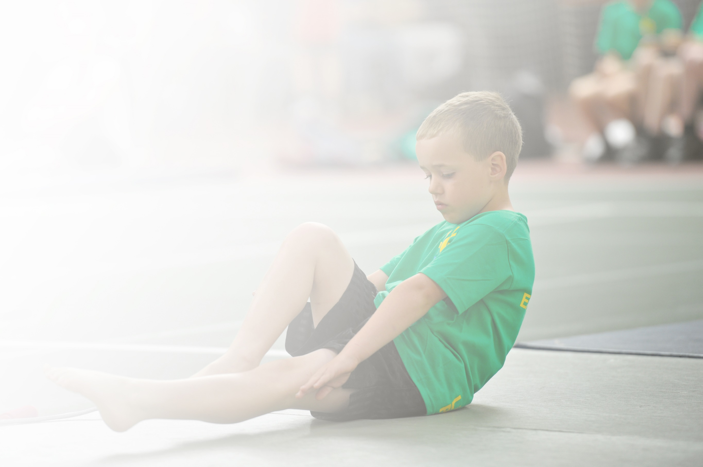
Schools must use the funding to make additional and sustainable improvements to the quality of Physical Education, Sport and Physical Activity (PESPA) they offer. This means that you should use the Primary PE and Sport Premium to:

- Develop or add to the PESPA activities that your school already offer
- Build capacity and capability within the school to ensure that improvements made now will benefit pupils joining the school in future years

Please visit gov.uk for the revised DfE guidance including the 5 key indicators across which schools should demonstrate an improvement. This document will help you to review your provision and to report
your spend. DfE encourages schools to use this template as an effective way of meeting the reporting requirements of the Primary PE and Sport Premium.

We recommend you start by reflecting on the impact of current provision and reviewing the previous
spend. Under the Ofsted Schools Inspection Framework, inspectors will assess how effectively leaders use the Primary PE and Sport Premium and measure its impact on outcomes for pupils, and how effectively governors hold them to account for this.

Schools are required to publish details of how they spend this funding as well as on the impact it has on pupils’ PE and sport participation and attainment by the end of the summer term or by 31 July 2019 at the
latest.
We recommend regularly updating the table and publishing it
on your website throughout the year, as evidence of your
ongoing review into how you are using the money to
secure maximum, sustainable impact. To see an
example of how to complete the table please
click HERE.

Support for review and reflection - considering the 5 key indicators from DfE, what development needs are a priority for your setting and your students now and why? Use the space below to reflect on previous spend, identify current need and priorities for the future.

Key achievements to date: | Areas for further improvement and baseline evidence of need:
NOTE: PE PROVISION 2020-2021 HAS BEEN SEVERELY CURTAILED BY COVID LOCKDOWN AND RESTRICTIONS IN PLACE DUE TO THE PANDEMIC.  - Children were able to access PE in their class bubbles due to systems and cleaning put in place  - Lunchtime sport took place on a rota with class bubbles and equipment cleaning systems in place  - New equipment purchased increased the range of activities available during class PE lessons e.g. table tennis and badminton  - PE coach developed his range of skills in offering non-equipment-based sport. E.g. Children took part in team building exercises and now better understand the need to work as a team in sport  - More children have developed a love for activity and have taken up sports outside of school  - Daily mile has enabled children to partake in physical activity during lockdown/pandemic restrictions | - To source swimming lessons  - To further develop lunchtime sport activities by training and utilising KS2 play leaders/sports ambassadors and signing up for the Healthy Lunchtimes initiative (Steve Harris and H&B sports partnership)  - To apply for the Sports award.  - To invite external experts in to inspire and motivate participation in sport.  - To provide further opportunities to participate in a wider range of sports e.g. rock climbing, outdoor adventure sports.  - To reintroduce wider participation in external competitions with DSAT and Hinckley and Bosworth partnership by signing up to H&S sports partnership  - Development of ABC teams to encourage participation at all levels and widen range of children able to participate in competitive sport

Meeting national curriculum requirements for swimming and water safety | Please complete all of the below:
What percentage of your current Year 6 cohort swim competently, confidently and proficiently over a distance of at least 25 metres?  N.B. Even though your children may swim in another year please report on their attainment on leaving  primary school. | COVID impact on swimming
What percentage of your current Year 6 cohort use a range of strokes effectively [for example, front crawl, backstroke and breaststroke]? | COVID impact on swimming
What percentage of your current Year 6 cohort perform safe self-rescue in different water-based situations? | COVID impact on swimming
Schools can choose to use the Primary PE and Sport Premium to provide additional provision for swimming but this must be for activity over and above the national curriculum requirements. Have you used it in this way? | No

Action Plan and Budget Tracking
Capture your intended annual spend against the 5 key indicators. Clarify the success criteria and evidence of impact that you intend to measure to evaluate for students today and for the future.

Academic Year: 2021/2022 | Total fund allocated: £ 17947.00  Cost of sports coaches Cost of sports coach £ 7010.60  Balance £10,936.40 | Date Updated: July 2021
Key indicator 1: The engagement of all pupils in regular physical activity – Chief Medical Officer guidelines recommend that primary school children undertake at least 30 minutes of physical activity a day in school |  |  |  | Percentage of total allocation:
 |  |  |  | 43%
School focus with clarity on intended impact on pupils: | Actions to achieve: | Funding allocated: | How we will evidence and impact: | Sustainability and suggested next steps:
- All classes will continue to participate in a daily ‘fun run’ around a course designed by the sports coach.  - Children will work towards achieving a whole school target of x miles run.  - Children will become fitter and participate daily in activity that is more vigorous.  - Children will be able to run further/faster than before.  - Ensure all children have opportunities to be active and engaged at lunchtimes  - To involve children in decisions about the sports provided.  - To increase pupil knowledge of sports rules and umpiring | - Sports coach to run lunchtime/after school sport  - Sports coach will set a target for whole school achievement  - Class teachers will monitor distance travelled  - Display results to encourage participation  - Rewards- class/child/school  - Undertake Happy Lunchtimes initiative  - Trina lunchtime staff  - Train KS2 children as sports ambassadors to provide activities for younger children | £7010.60  (also for KI 4&5)  £675 | - Class teachers will evidence distance travelled by their class  - Photos and display  - Children will become fitter and be able to cover more distance as time goes on  - Monitor children to see wider participation and leadership in sports and have increased opportunities to be physically active.  - Monitor range/effectiveness of activities provided at lunchtime | - Project was highly engaged with last year by students and staff. Will continue.  - Provide incentives/ rewards to maintain interest, termly medals, certificates etc.  - Visible display of achievements.  - Review provision termly  - Identify/train new leaders for continuity of provision  - Ensure lunchtime staff training is refreshed annually
Key indicator 2: The profile of PESSPA being raised across the school as a tool for whole school improvement |  |  |  | Percentage of total allocation:
 |  |  |  | 0% see KI 5
School focus with clarity on intended impact on pupils: | Actions to achieve: | Funding allocated: | How we will evidence and impact: | Sustainability and suggested next steps:
- PE lessons and fitness opportunities include a focus on the health and wellbeing aspects of keeping fit following COVID lockdown period.  - Children and staff further develop their understanding of the mental wellbeing and health benefits of taking exercise.  - Pupils will participate in trust/H&B events and this will be celebrated in assemblies.  - Fossebrook will host events | - Ensure children participate in daily fitness activities to improve fitness and mental wellbeing following school closure for COVID pandemic.  - Ensure PE/PHSE lessons cover benefits of physical activity for mental health and wellbeing  - Plan events for attendance for all age groups.  - Host events for other schools to attend | No cost  See KI 5 | - Planning included sessions around mental health and fitness benefits, which support school curriculum work on healthy lifestyles.  - Monitor children who attend trust events Fossebrook hosting events raises the profile of PE/participation in clubs further across the school. | - Embedded in curriculum offer.  - May be affected by COVID pandemic issues

Key indicator 3: Increased confidence, knowledge and skills of all staff in teaching PE and sport |  |  |  | Percentage of total allocation:
 |  |  |  | 3.5%
School focus with clarity on intended  impact on pupils: | Actions to achieve: | Funding  allocated: | How we will evidence and impact: | Sustainability and suggested  next steps:
- Sports coach to attend DSAT/H&B network meetings and training in order to develop professional knowledge and skills in the delivery of PE leading to high quality provision for all children.  - Sports coaches to receive training in specific sports e.g. football coaching, teaching PE in primary schools  - Lunchtime staff will deliver active learning opportunities | - Sports coach is released/paid overtime to attend sports network meetings for training and planning of fixtures.  - Sports coaches to audit skill set and identify areas for professional development  - Sports coach to select training modules from H&B training programme  - Sports coach to train lunchtime staff in effective delivery of activities | £100  £535 | - Sports coach is more confident in the delivery of areas of PE and the quality/range of sport offered is of an excellent standard  - Monitor lunchtime provision and uptake | - High level of planning available to all staff to develop knowledge in the delivery of PE activities.  - Staff CPD offer may be compromised by COVID pandemic-availability of courses
Key indicator 4: Broader experience of a range of sports and activities offered to all pupils |  |  |  | Percentage of total allocation:
 |  |  |  | 22.5%
School focus with clarity on intended  impact on pupils: | Actions to achieve: | Funding  allocated: | How we will evidence and impact: | Sustainability and suggested  next steps:
- Increased participation in sport through a range of non-traditional opportunities being offered e.g. rock climbing.  - Invite sporting experts to share their knowledge of a broader range of sports.  - Survey pupils to see what additional sport they would like to take part in. | - Source resources e.g. rock climbing wall etc  - Identify experts through sport England etc. to visit school and provide activities  - Source new resources | £2976.40  £1000 | - Photographs, displays, assemblies.  - Increased uptake in sports  - Pupil surveys | - Dependent on funding  - Outcomes of pupil survey to plan next events
Key indicator 5: Increased participation in competitive sport |  |  |  | Percentage of total allocation:
 |  |  |  | 31%
School focus with clarity on intended  impact on pupils: | Actions to achieve: | Funding  allocated: | How we will evidence and impact: | Sustainability and suggested  next steps:
- Participate in DSAT/H&B partnership competitions to allow children to participate in competitive sport and experience a wider range of opportunities, to compete with children from other schools and benefit from specialist venues and coaches.  - Develop inter house sport within school to enable all children to participate in competitive sport. | - Enrol in H&B sports partnership  - Ensure sufficient funding allocated to transport  - Sports coach to diarise fixtures and book transport for these and communicate in a timely fashion with parents.  - Plan for additional competitive opportunities within the school year.  - Purchase additional uniform | £4000 transport and £650 subscription fees  £1000 | - Children from more year groups are able to participate in competitive sports.  - Teams are increasingly successful due to regular competitive opportunities. | - Try to share transport costs to increase number of competitions we can take part in or the number of children that can attend.  - Liaise with SLT to plan inter house events.

